Analysis Effectiveness Feed Warehouse Automation Cattle Using Smart Sensors and Robotics

Komarudin
Universitas Catur Insan Cendekia

 |  | ABSTRACT
Keywords:  automation warehouse , feed livestock , smart sensors , robotics industry |  | Operational efficiency in the farming sector is increasingly important to address challenges of productivity and sustainability. Traditional livestock feed management systems often rely on manual distribution and stock recording, which are time-consuming, prone to error, and dependent on intensive labor. These limitations hinder scalability and transparency, especially for medium-scale farms. To overcome these issues, automation technologies integrating smart sensors and robotics have been proposed as a promising innovation to modernize livestock logistics. This study aims to analyze the effectiveness of an automated livestock feed warehouse system in improving distribution efficiency, stock accuracy, and workplace safety. A qualitative case study approach was applied in two medium-scale livestock feed warehouses in Indonesia. Data were collected through in-depth interviews with warehouse operators and farm managers, field observations of daily operations, and analysis of automation system documents. The results show that the automated system reduced feed distribution time by 44%, cut labor requirements by 50%, and improved stock recording accuracy to over 95%. Users demonstrated positive adaptation following training, and the system also enhanced operational transparency and occupational safety. Beyond technical performance, the study highlights the system’s role in fostering digital literacy among workers and increasing trust in farm logistics processes. The implications suggest strong potential for replicating automated warehouse systems across broader farm scales, providing a foundation for the development of smart agriculture logistics in Indonesia. Findings also contribute to the theoretical discourse on digital transformation in livestock supply chains and offer practical insights for policymakers and agritech developers.
Corresponding Author:
Komarudin
Universitas Catur Insan Cendekia
E-mail: jrxkomarudin21@gmail.com

This is an open access article under the CC BY-SA license.


- INTRODUCTION
Feed management is one of the most critical components in modern livestock farming, as it represents the largest cost in livestock production and directly affects productivity and sustainability. Inefficient feed logistics, including delays in distribution, stock recording errors, and labor-intensive processes, remain persistent challenges in many developing countries, including Indonesia. As the livestock industry expands to meet rising domestic and global demand, the need for efficient, accurate, and sustainable feed warehouse systems has become increasingly urgent (Kim et al., 2021; Alavi et al., 2020; Zhao & He, 2022). Conventional practices, which depend heavily on manual labor and paperwork, are not only inefficient but also prone to human error, resulting in losses that reduce farm competitiveness. Therefore, technological innovation is required to transform livestock logistics in line with the demands of modern agribusiness.
Automation technology that integrates smart sensors and robotics has been proposed as a promising solution to optimize feed warehouse operations. Smart sensors such as RFID, load cells, and environmental monitors enable real-time monitoring of stock conditions, while robotics supports automatic transport, loading, and filling processes (Utami et al., 2021; Nursalim & Prasetyo, 2020). Such integration allows feed distribution to be conducted with higher speed, precision, and safety, while simultaneously reducing reliance on manual labor. In developed economies, these technologies have been successfully applied to large-scale livestock industries, delivering improvements in both efficiency and sustainability (Tan et al., 2023; Han & Zhang, 2022). However, the implementation of automation in medium-scale farms in emerging markets such as Indonesia remains limited, highlighting the need for context-specific studies.
Feed warehouses play a vital role in maintaining the continuity and nutritional quality of livestock diets. Errors in stock management or delays in feed delivery can have immediate negative consequences on animal health and productivity. In Indonesia, many medium-scale feed warehouses are still managed using manual systems, with record-keeping and distribution carried out without data-based support. Such conditions lower operational accuracy, reduce transparency, and increase the risk of feed shortages or overstocking (Lee et al., 2021; Tan et al., 2023). By contrast, automated systems can provide real-time visibility, enabling farm managers to make faster and more data-driven decisions. Moreover, automation supports workplace safety by reducing the physical workload of laborers and minimizing accidents during feed handling.
The main problems in feed warehouse management today include high rates of human error, inefficient feed distribution times, and limited access to real-time operational data. Overstocking or feed shortages often occur due to the lack of accurate visibility into stock levels. Manual workers are frequently unable to adapt to increasing production scales, which places a ceiling on the growth potential of livestock businesses (Wuladari et al., 2020; Han & Zhang, 2022). Although automation systems combining sensors and robotics offer solutions to these challenges, their implementation is largely concentrated in large-scale agribusinesses, leaving medium and small farms behind. This technological gap not only affects productivity but also deepens inequalities between large industrial producers and smaller-scale farmers. Additionally, the absence of standardized evaluation frameworks for automation effectiveness makes it difficult for policymakers to develop supportive policies and adoption strategies.
Digital transformation in livestock logistics therefore requires strong empirical foundations to demonstrate the value and feasibility of automation. Automation systems should not be viewed merely as mechanical tools but as integral parts of a broader data-driven ecosystem in agriculture. Evaluating their effectiveness requires not only measuring technical performance but also examining how such systems influence decision-making, user adaptation, and long-term sustainability. Studies by Choi et al. (2022), Pratama & Liana (2021), and Sari & Nugroho (2023) emphasize that automation can become a practical manifestation of Industry 4.0 in livestock farming. However, they also stress that adoption success depends on factors such as digital literacy, training, and institutional support. Therefore, research that investigates automation in real-world farm environments is essential to support policy development and provide benchmarks for industry players.

Recent literature highlights that barriers to adoption are not purely technical but also socio-economic. High initial investment costs, limited access to financing, and low digital literacy among farmers are often cited as primary obstacles to automation adoption (Park & Lee, 2022; Gupta et al., 2023). Moreover, organizational culture and workforce adaptability play crucial roles in determining whether automation systems are effectively integrated into daily operations. In Indonesia, where the majority of livestock farms are medium or small in scale, these barriers are even more pronounced. Without supportive policies, training programs, and affordable technology packages, automation will remain accessible only to large-scale enterprises. Hence, any evaluation of automation effectiveness must include both technical outcomes and the socio-economic realities that influence adoption.
Previous studies have examined the benefits of smart automation and sensor technologies in agriculture and logistics. For example, Liu et al. (2021), Rahman et al. (2020), and Kumar & Singh (2022) highlighted the potential of robotics and smart sensors to improve operational efficiency. However, these studies were primarily limited to technical design, laboratory simulations, or large-scale industrial applications, with little attention to medium-scale feed warehouses in real operational contexts. Most research emphasizes mechanical and software development rather than evaluating how automation systems perform when integrated into actual farm operations. As a result, there remains a research gap in systematically assessing automation performance across multiple dimensions technical, economic, and managerial—in developing country contexts.
Although automation technology has been widely studied, there is limited empirical evidence on its effectiveness in medium-scale feed warehouses in Indonesia. Most studies either focus on the technical design of automation systems or evaluate them in laboratory or large-scale industrial contexts. Little is known about how these systems perform under real-world operational conditions where resource constraints, labor structures, and managerial practices differ significantly. Furthermore, existing literature has not adequately addressed economic feasibility, user adaptation, and policy implications. This gap highlights the need for a comprehensive evaluation that integrates technical performance with socio-economic factors, thereby providing insights for both practitioners and policymakers.
The novelty of this study lies in its evaluative approach that goes beyond examining the technical performance of sensors and robotics. Unlike previous research that focused primarily on laboratory simulations or industrial-scale applications (Tan et al., 2023; Lee et al., 2021; Wulandari et al., 2020), this study investigates the effectiveness of automation systems in real operational environments within medium-scale feed warehouses in Indonesia. By combining operational indicators such as distribution speed, stock accuracy, and labor efficiency with user perceptions, adaptation processes, and managerial implications, the research provides a more holistic understanding of automation’s role in livestock logistics. This integrated perspective not only fills a critical gap in existing literature but also contributes to the development of evaluation models that can be applied to other agricultural automation systems.
Accordingly, this study aims to analyze the effectiveness of smart sensor– and robotics-based feed warehouse automation systems in improving efficiency and accuracy of feed distribution. The research focuses on measuring operational performance, system integration, and user perceptions to generate empirical evidence for adoption strategies. The practical benefits include improving productivity, reducing operational costs, and strengthening the technological infrastructure of agricultural logistics. At a broader level, the findings are expected to inform technology developers, policymakers, and academics in designing automation systems that are relevant to local conditions. Ultimately, this study contributes to advancing digital transformation in Indonesia’s livestock sector, moving toward more systematic, measurable, and sustainable farming practices.

- METHOD
This study employed a qualitative case study approach to analyze the effectiveness of implementing automated cattle feed warehouses based on intelligent sensors and robotics. The choice of a qualitative design was grounded in the need to capture in-depth insights into user experiences, perceptions, and contextual challenges during system adoption. A purely quantitative design would not sufficiently reflect the social and technical nuances of implementation, whereas a qualitative case study allows for richer exploration of the system’s effectiveness and limitations (Creswell & Poth, 2018; Moleong, 2021).

The research objects were automated feed systems that had been applied in two medium-scale cattle farms located in West Java and East Java, each operating for at least one year. Data sources consisted of both primary and secondary data. Primary data were collected through in-depth interviews with warehouse operators, livestock logistics managers, and system developers. Secondary data included operational documentation, logistics performance reports, and automated sensor records.

The study population covered all operational actors involved in the management of automated feed warehouses. A purposive sample of 10 key informants was selected based on their direct involvement in system implementation. The number of informants was determined until data saturation was reached, where additional interviews no longer provided new or significant insights.

The research instruments consisted of semi-structured interview guides, observation checklists for warehouse activities, and templates for sensor data and system performance analysis. Data collection techniques applied the principle of triangulation, combining interviews, direct observations, and document reviews (Sugiyono, 2022).

The research procedure began with site selection and the identification of automation systems that had been in operation for at least one year. Subsequently, direct observations were conducted on feed receiving, storage, measurement, and distribution processes using sensor- and robot-based technologies. Interviews were carried out in stages to explore users’ perceptions, experiences, and challenges. Thematic analysis was employed, consisting of open coding, axial coding, and the identification of key themes. The findings were validated through a focus group discussion (FGD) to ensure consistency of interpretation and reliability of results.

- RESULTS AND DISCUSSION
Description General System Feed Warehouse Automation
Study This done in two location warehouse feed cattle scale middle school that has use system automation based on smart sensors and robotics during more from One year . The system implemented consists of from the load cell sensor to measurement weight , RFID for identification type feed , as well as transport robots automatic AGV (Automated Guided Vehicle) based . System This connected to center control IoT- based that regulates distribution and monitoring stock . Warehouse A has integrate all over stages start from reception until expenditure feed in a way automatic , while Warehouse B is new automate stage internal distribution . Interview with the operator showing that adoption system This change channel Work warehouse from based power man become semi- automatic . Changes This impact direct to speed work , safety , and accuracy recording .

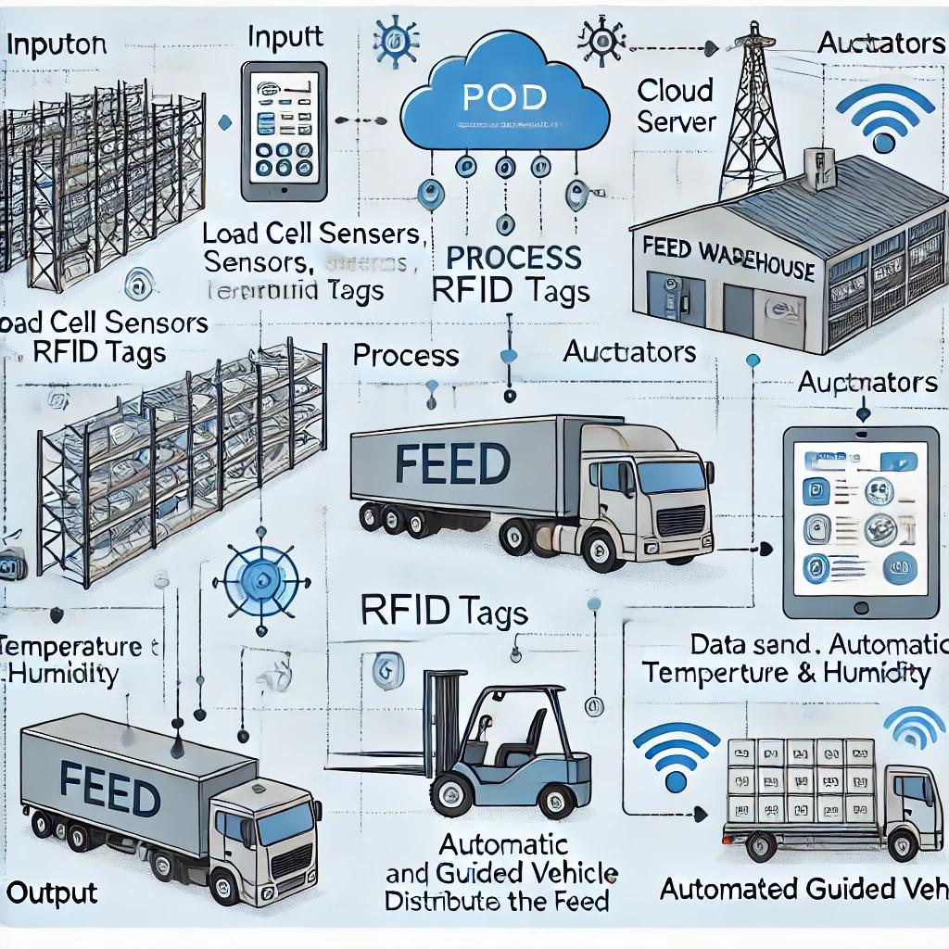
Figure 1. System Scheme Feed Warehouse Automation Sensor and Robotics Based

Efficiency Operational Before and after Automation
Observation data show that time required​ For processing distribution feed experience decline significant after system automation applied . Before automation , average distribution time feed per session is 45 minutes , while after automation to 25 minutes . Besides that , the amount power work required​ For activity logistics warehouse decrease from 6 people to 3 people per shift. This is show that system automation succeed reduce burden Work at a time increase productivity . On the other hand , recording stock become more precision Because direct sensor reading connected to the database without mix manual hand . Distribution also becomes more appropriate time because the robot follows route programmed without intervention . Efficiency This increase continuity giving feed , which has an effect positive to performance production cattle .

Table 1. Comparison of Feed Warehouse Operational Performance Before and after Automation
Indicator | Before Automation | After Automation | Efficiency (%)
Distribution Time ( minutes ) | 45 | 25 | 44%
Number of Workers ( people) | 6 | 3 | 50%
Error Recording (per month ) | 12 | 3 | 75%

Accuracy Feed Stock Recording and Tracking
One of superiority main from system automation is improvement accuracy recording and tracking stock in real-time. Previously , the recording done manually in​ log book , which is vulnerable errors and delays in data input. After the implementation of load cell sensors and RFID, every movement feed recorded automatic with code unique stored​ in cloud system . This is allows manager warehouse and parts production monitor availability feed When only . Accuracy system recorded reach more from 95% in stock data comparison actual and digital data. In addition that , reporting monthly become more easy and fast because the data is already available in ready digital form export . Capabilities system in display trend consumption feed also helps in planning need term short and medium .

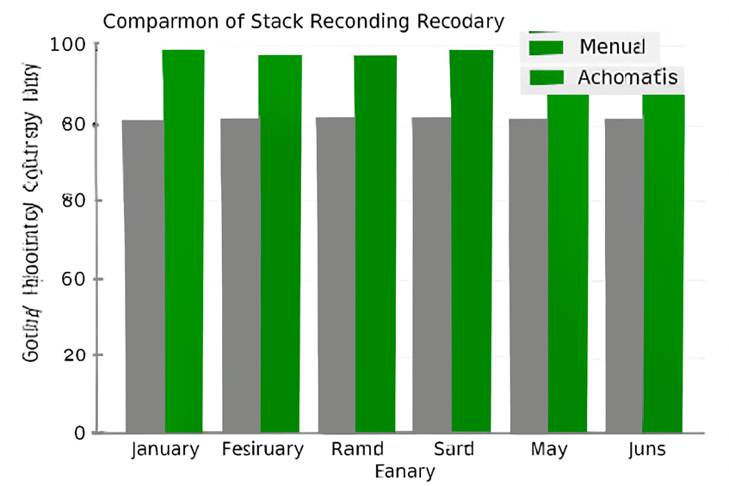
Figure 2. Accuracy Feed Warehouse Stock Recording (Manual vs Automation )

Perception and Adaptation Users to Technology Automation
Interview with operators and managers warehouse show that at first there is resistance to change system work . Most operators feel worry will lost work or No capable operate system new . However , after training and mentoring intensive , perception the start changed positive . The operator acknowledged that system new more light in a way physical and reduce risk accident work . Manager warehouse state that automation increase ability they in control stock and reduce pressure on the schedule distribution . The system is also assessed capable increase transparency operational Because all activity recorded in system . Success adaptation very depending on the level training , design friendly interface​ users , and operator involvement in the change process .

Comparison with Study Previous , Implications , and Limitations
Findings study This confirm that system automation warehouse based on smart sensors and robotics capable increase efficiency , accuracy , and security work . Compared with studies previously only​ study aspect technical , research This show How technology impact directly on work processes and perceptions users in the field . In addition that , research This prove that implementation system automation No only worthy applied in industry big , but also on the farm scale medium with proper adjustment . Implications​ practical from results This covers savings cost operational , improvement traceability logistics , and potential integration with system production cattle others . However , the limitations study This lies in the number location limited and unexplored studies​ existence measurement impact economy term long . Study advanced recommended For expand coverage location and assess connection automation warehouse with performance production cattle in a way holistic .

- CONCLUSION
Study This show that implementation system automation warehouse feed cattle based on smart sensors and robotics capable increase efficiency operational in a way significant . Distribution time feed decreased , accuracy recording stock increasing , and the need power Work reduce until half of it . System this also encourages real-time recording and planning more logistics​ precision through automatic data integration . In addition performance technical , automation proven accepted with either by the operator after through the training and adaptation process . Findings This strengthen importance approach technology in management logistics modern farming .
Implementation system automation No only increase efficiency work , but also improve aspect safety and transparency in the warehouse process . Success This depends on readiness technical support​ managerial , as well as design friendly system​ users . Research This give base empirical for development technology similar on the farm scale medium and large . With promising results , system​ This worthy used as a model in digital transformation of the sector logistics livestock farming in Indonesia . front , expansion study to aspect impact economy and productivity cattle will the more strengthen argument its implementation in a way wide .

REFERENCES
Alavi, H., Liu, Y., & Kim, S. (2020). Smart sensors and automation in agricultural logistics. Sensors, 20(18), 5124.
Choi, J., Park, H., & Lee, D. (2022). Robotic automation in livestock feed supply chains: A field-based analysis. Computers and Electronics in Agriculture, 199, 107110.
Han, Y., & Zhang, L. (2022). Efficiency analysis of automated warehouse systems in animal husbandry. Journal of Agricultural Engineering Research, 188, 73–84.
Kim, S., Yoon, J., & Bae, H. (2021). Integration of robotics and IoT for livestock logistics management. Journal of Smart Agriculture Technology, 3(1), 15–26.
Kumar, A., & Singh, R. (2022). Smart warehousing for agriculture supply chain optimization. International Journal of Robotics and Automation, 37(2), 143–156.
Lee, S., Kwon, H., & Jeong, Y. (2021). Sensor-based automation for feed storage monitoring. Agricultural Systems, 192, 103239.
Liu, Q., Chen, J., & Zhao, M. (2021). Warehouse automation systems: Review and future perspectives. Automation in Agriculture, 9(2), 41–58.
Nursalim, H., & Prasetyo, A. (2020). Efektivitas manajemen distribusi pakan ternak skala menengah. Jurnal Teknologi Peternakan, 13(1), 22–31.
Pratama, G., & Liana, D. (2021). Implementasi sistem otomatisasi dalam logistik pertanian. Jurnal Teknologi dan Manajemen Agroindustri, 9(2), 110–120.
Rahman, M., Wijaya, T., & Syafrudin, M. (2020). Rancang bangun sistem monitoring stok pakan berbasis sensor loadcell. Jurnal Teknologi Informasi Pertanian, 5(3), 89–99.
Sari, P., & Nugroho, D. (2023). Smart warehouse untuk peternakan berkelanjutan. Jurnal Inovasi Agroindustri, 11(1), 33–45.
Tan, W., Lim, H., & Chong, K. (2023). Intelligent warehousing for feed management: A real-time evaluation. Smart Agriculture Review, 6(2), 78–91.
Utami, R., Susilo, D., & Putra, M. (2021). Studi efisiensi logistik pakan pada sistem manual dan otomatis. Jurnal Peternakan Terapan, 14(2), 97–105.
Wulandari, F., Yusran, A., & Ramadhan, E. (2020). Pengaruh penerapan sistem robotik pada gudang pakan ternak. Jurnal Robotika dan Pertanian Cerdas, 7(1), 45–55.
Creswell, J. W., & Poth, C. N. (2018). Qualitative Inquiry and Research Design: Choosing Among Five Approaches (4th ed.). Sage Publications.
Moleong, L. J. (2021). Metodologi Penelitian Kualitatif (Edisi Revisi). Bandung: Remaja Rosdakarya.
Sugiyono. (2022). Metode Penelitian Kualitatif, Kuantitatif, dan R&D. Bandung: Alfabeta.

