Evaluation Sustainability Agriculture Precision Based Robotics and Sensors against Efficiency Use Source Water Power

Aulia Rizki
IPB University, Bogor Indonesia

 |  | ABSTRACT
Keywords:  agriculture precision , water efficiency , smart sensors , sustainability |  | Precision agriculture has emerged as a strategic solution to address the challenges of water resource efficiency, particularly in tropical regions that are highly vulnerable to recurring water crises. While existing studies have highlighted the potential of precision irrigation, limited research has focused on the integration of robotics and sensor-based systems in tropical agricultural contexts. This study aims to evaluate the sustainability and effectiveness of precision agriculture systems that utilize soil moisture, weather, and automated irrigation sensors to optimize water use. A qualitative case study approach was employed in two tropical agricultural sites in West Java and East Java, Indonesia, where precision irrigation systems have been implemented for more than one year. Data were collected through in-depth interviews with farmers and system operators, field observations, and sensor documentation, and subsequently analyzed using thematic analysis. The findings indicate a significant reduction in irrigation water consumption of up to 42%, improved accuracy of water distribution, and a decrease in manual labor requirements. Farmers also demonstrated high acceptance of the system after undergoing training and adaptation processes. This research contributes novel insights into the practical sustainability of sensor- and robotics-based precision agriculture in tropical settings, highlighting its role in advancing efficient, adaptive, and climate-resilient water management practices.
Corresponding Author:
Aulia Rizki
IPB University, Bogor Indonesia
E-mail: aulia.rizki8080@gmail.com
This is an open access article under the CC BY-SA license.


- INTRODUCTION
Agriculture is the largest consumer of global freshwater, accounting for nearly 70% of withdrawals worldwide (FAO, 2022). In many regions, conventional irrigation practices remain inefficient, with water losses from leakage, evaporation, and poor distribution reaching as high as 40% (Zhou et al., 2022). These inefficiencies are especially critical in tropical countries where rainfall is seasonal and extreme weather events are becoming more frequent due to climate change. The resulting water scarcity poses serious risks to food security, rural livelihoods, and ecological sustainability. Addressing these challenges requires innovative approaches to optimize water use and improve resource efficiency without undermining agricultural productivity.
One promising solution is precision agriculture, which integrates robotics, sensors, and digital technologies to enable data-driven decision-making in farming. By deploying soil moisture sensors, weather-based monitoring systems, and automated irrigation, precision agriculture allows farmers to regulate water use more effectively while reducing labor intensity. Studies in temperate regions have demonstrated significant benefits, such as improved crop yields and reduced environmental impact through more efficient irrigation (Aravindakshan et al., 2020; Lee & Park, 2021). These advancements highlight the transformative potential of precision agriculture, particularly in optimizing scarce water resources.
Despite these opportunities, the adoption of precision irrigation systems in tropical regions remains limited. Several barriers hinder widespread implementation, including high initial investment costs, lack of infrastructure, insufficient technical training, and cultural resistance among smallholder farmers (Kumar et al., 2021; Santoso & Haryono, 2023). Moreover, many available studies focus primarily on technical efficiency or device-level performance, often neglecting broader socio-economic and environmental dimensions. This gap suggests that while the technology has been proven in principle, its sustainability and scalability in tropical agricultural settings remain underexplored.
The urgency of such exploration is amplified by the increasing vulnerability of tropical agriculture to climate change. In Indonesia, for example, seasonal droughts affect more than 3 million hectares of irrigated farmland each year, threatening staple food production and rural stability (BPS, 2023). The World Bank (2022) warns that water demand in Southeast Asia could rise by 30% by 2040, intensifying competition among agricultural, industrial, and domestic users. In this context, sustainable irrigation strategies are not only desirable but essential. Precision agriculture, with its potential to conserve resources while maintaining productivity, offers a strategic response to these urgent challenges.
Existing research has documented some positive outcomes of precision irrigation. Zhou et al. (2022) highlighted the role of soil moisture sensors in reducing water consumption in rice fields, while Lee and Park (2021) emphasized the efficiency of automated irrigation in urban horticulture. However, these studies are often context-specific and focus narrowly on technical outcomes, overlooking important sustainability aspects such as farmer acceptance, operational costs, and long-term adaptability in tropical environments. Thus, there is a critical need for empirical research that combines technical assessment with socio-economic and environmental evaluations.
This study seeks to address that gap by conducting an integrative evaluation of robotics- and sensor-based precision agriculture systems in tropical agricultural contexts. The research investigates not only water-use efficiency and irrigation accuracy but also farmer perceptions, training needs, and sustainability dimensions. By combining sensor-based data with qualitative insights from farmers, the study provides a multi-dimensional perspective on the feasibility of precision irrigation. The novelty of this research lies in its dual focus: assessing both technical performance and sustainability outcomes under tropical climatic and socio-economic conditions, where technology adoption has historically been low but is urgently needed.
Accordingly, this study has three key objectives. First, it evaluates the technical efficiency of precision irrigation systems, specifically their ability to reduce water losses and improve distribution accuracy. Second, it assesses the broader sustainability of these systems, including environmental impacts, cost efficiency, and farmer acceptance. Third, it develops evidence-based recommendations for policymakers, practitioners, and agricultural stakeholders to support adaptive water management strategies in tropical farming. The findings are expected to contribute both theoretically—by advancing the literature on sustainable precision agriculture—and practically—by informing strategies that strengthen food security and water resource resilience in the era of climate change.

- METHOD
This study employed a qualitative descriptive approach with a case study design to evaluate the sustainability of precision agriculture systems based on robotics and sensor technologies in enhancing water-use efficiency. The research focused on two tropical agricultural regions, namely Sleman Regency and Subang Regency, where precision agriculture practices had been applied to horticultural and food crop lands. The choice of a qualitative method was grounded in the need to capture the complex social, technical, and environmental dimensions of technology adoption, which could not be adequately explained through quantitative measurements alone. Such an approach allows for a deeper understanding of farmer perceptions, behavioral adaptation, and contextual challenges related to sustainability.
The data sources consisted of both primary and secondary data. Primary data were collected through in-depth interviews with farmers, system technicians, and agricultural extension officers, alongside direct observations of automatic irrigation systems utilizing sensor-based technology. Secondary data included water management documentation, energy consumption reports, and irrigation sensor records. The study population comprised all farming actors applying precision agriculture systems in the selected areas, with the sample determined purposively. A total of 12 key informants were selected, representing diverse roles in the management and use of water-based agricultural technologies. This sample size was deemed sufficient as thematic saturation was achieved during the data collection process, ensuring no new significant information emerged after the twelfth participant.
The research instruments consisted of semi-structured interview guides, observation checklists for water-use efficiency, and sustainability assessment forms. Data collection was conducted triangulatively, combining interviews, field observations, and document analysis to enhance the validity of findings. The fieldwork was carried out over three consecutive months, beginning with mapping the areas where sensor-based precision agriculture systems were implemented. Interviews focused on exploring user perceptions of the technology’s impact on water efficiency and production sustainability. Observations were used to record irrigation frequency, water distribution duration, and environmental conditions before and after system implementation.
Data analysis followed a thematic procedure, starting with open coding to identify emerging concepts, followed by axial coding to establish relationships between themes. Categories such as water-use efficiency, technical sustainability, and social acceptability were developed to structure the analysis. The credibility and dependability of the findings were further enhanced through member checking and focus group discussions with farmers and precision agriculture experts, providing opportunities to validate and refine interpretations.
The overall research procedure can be represented as a stepwise process beginning with site mapping, followed by data collection through interviews, observations, and documentation, then thematic coding and analysis, and finally validation through group discussions. This stepwise approach ensured methodological rigor while allowing flexibility to capture the complexity of local agricultural practices.

- RESULTS AND DISCUSSION
System Structure and Integration Agriculture Precision
System agriculture precision studied in two​ location studies consists of on humidity sensor combination soil , weather sensors , control irrigation automatic , and robotic units regulator water distribution . Data from the sensors is sent in real-time to system center through network wireless and processed by the device soft cloud -based . Farmers can access information This through application mobile For monitor condition land and plant water requirements . At location A, the system integrated full since stage processing land until irrigation ; whereas at location B, the system only covers irrigation automatic . System robotics functioning directing water to the plant zones that need it based on sensor output. This integration help reduce frequency excessive watering and adjust the water volume accordingly need actual . Interview results show that users feel more believe self take decision irrigation Because existence data support .

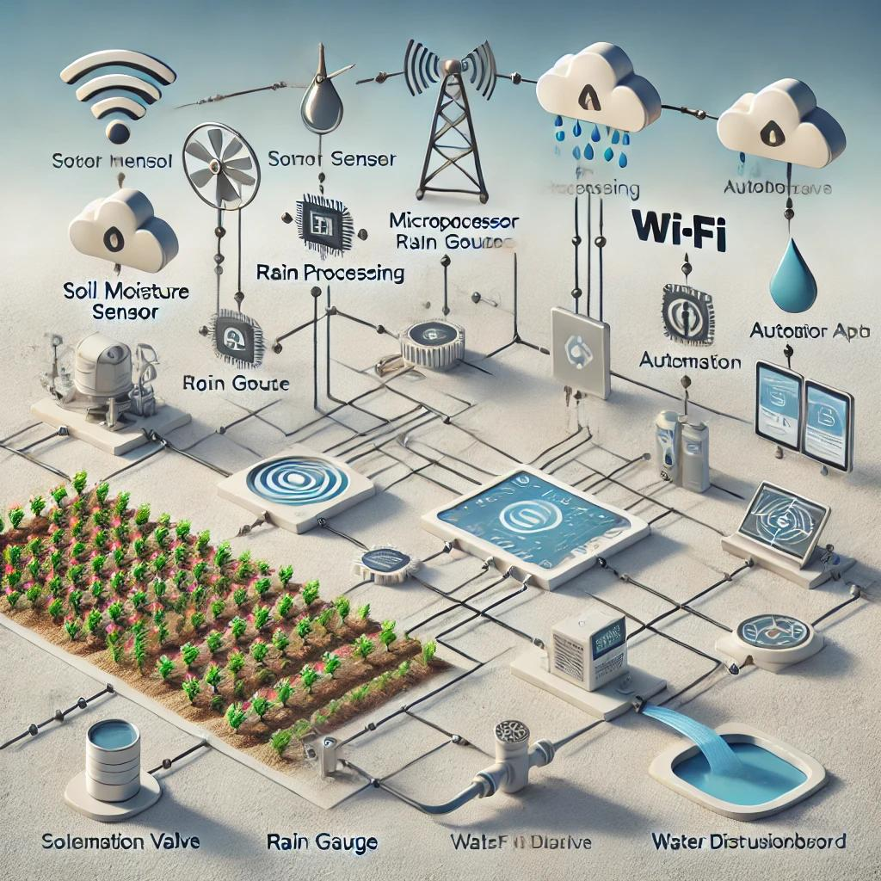
Figure 1. System Diagram Agriculture Precision Sensor and Robotics Based

Efficiency Water Use Before and After Implementation System
Observation results show existence decline significant in the volume of irrigation water use in both location after implementation system precision . At location A, the volume of water use per hectare decrease from 4,500 liters to 2,600 liters per week . Meanwhile that , at location B it happened decline from 4,200 liters to 2,800 liters per week . The decrease This caused by the system only activate irrigation when the sensor detects level humidity below​ threshold limit critical . Besides that , duration watering become more short Because efficiency increased water absorption with volume and pressure settings in a way automatically . With Thus , efficiency increased water use up to 38–42% compared to method conventional . Impact this also reduces burden on local water sources and contribute to conservation term long .

Table 1. Comparison of Water Usage Volume (Liters/ Hectare / Week )
Location | Before Precision | After Precision | Efficiency (%)
A | 4,500 | 2,600 | 42.2%
B | 4,200 | 2,800 | 33.3%

Impact Environment and Adaptation System to Climate Tropical
Implementation system precision participate give impact to condition environment micro around​ land agriculture . At location A, there are decline humidity land excess of the previous trigger growth weeds and fungi . With more water distribution controlled , quality land and health plant increase in a way overall . The system is also proven capable adapt with fluctuations weather tropical which is not uncertain , with a weather sensor that automatically automatic postpone watering moment happen rain . This result show that technology capable replace intuition farmers who have been This depending on the forecast subjective . The interview also revealed that system more effective on types plant horticulture compared to plant rice that is still need puddles . This is give notes that adaptation technology need consider characteristics commodities and conditions agroecology local .

Perception Users and Acceptance Social
Most of the users system state that use technology precision give comfort and efficiency work , even at the beginning implementation had time cause resistance . Farmers mention that training and mentoring technical is factor key in success adaptation system . At location A, 80% of farmers active use application For monitor condition land , while at location B, only 60% are routine access the digital dashboard. Factors age , experience use technology , and availability internet network also influence acceptance technology . Most of respondents state that they will recommend system This to other farmers if available support subsidies and training continued . Differences perception This show importance human-centered approach in implementation technology agriculture . Combination between reliability technology and comfort users become key success sustainability system precision in the field .
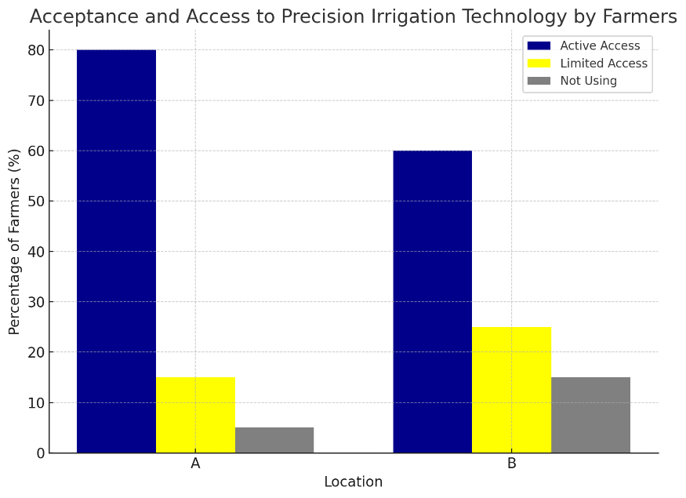
Figure 2. Acceptance Level System Precision by Farmers (%)

Comparison with Study Previously , Implications Practicality and Limitations
Research result This support findings previously stated​ that system precision can save water and improve efficiency agriculture . However , research This expand context with evaluate sustainability from side social , environmental , and technical in a way simultaneously . Besides that , research This carried out in tropical areas , which during this is minimally used location studies system precision . Implications practical from results This covers the need support policy For expand implementation system precision through training , subsidies devices , and reinforcement digital infrastructure . Developers technology is also necessary designing flexible and adaptable system​ customized with condition local . As for the limitations study This is amount location limited and unexplored studies​ covers analysis impact economy in a way measurable . Research advanced recommended For explore connection between water efficiency , improvement results harvest , and reduction production input costs in a way holistic .

- CONCLUSION
Study This show that agriculture precision based robotics and sensors can increase efficiency water use​ significant on land agriculture in tropical regions . The system irrigation integrated automatic​ with humidity and weather sensors capable reduce water consumption without sacrifice productivity plants . Besides efficiency technically , the system also has an impact positive to condition environment micro and health land . Adaptation system to variability climate local prove flexibility technology This in context tropical . Therefore that , the implementation technology This assessed worthy and supportive sustainability management source deep water power agriculture .
Besides benefit technical , success the system is also influenced by perception and involvement users at the level field . Support training and digital infrastructure become factor important in push adoption technology in a way extensive research​ This confirm importance approach holistic which includes aspect technical , social and environmental in evaluate sustainability technology agriculture precision . This result give base strong For development policies and programs that encourage digital transformation of the sector agriculture . With Thus , agriculture precision can become important pillars in realize system production sustainable and adaptive food​ to change climate .

REFERENCES
Aravindakshan, S., Krupnik, T. J., & Rossi, F. (2020). Adoption barriers of precision agriculture technologies in developing countries. Agricultural Systems, 180, 102774.
Chen, Q., Li, H., & Wu, Y. (2021). Assessing water-saving potential of precision irrigation systems. Irrigation Science, 39(3), 267–280.
Kumar, R., Singh, R., & Kaur, J. (2021). Water use efficiency in precision agriculture: A case study in semi-arid regions. Journal of Precision Agriculture, 22(4), 553–567.
Lee, J., & Park, S. (2021). Application of smart irrigation systems in urban agriculture. Agricultural Water Management, 248, 106754.
Li, X., & Zhang, W. (2023). Integrated assessment model for precision agriculture and water management. Sustainability, 15(1), 845.
Liu, H., Wang, J., & Sun, T. (2020). Precision irrigation for sustainable agriculture: A review. Environmental Monitoring and Assessment, 192(9), 567.
Nugroho, M., & Ardiansyah, A. (2021). Transformasi digital pertanian berbasis teknologi presisi di Indonesia. Jurnal Pertanian Cerdas, 5(2), 101–115.
Raharjo, T., Suryani, E., & Maulana, R. (2022). Analisis keberlanjutan irigasi berbasis teknologi cerdas. Jurnal Agroekoteknologi Tropika, 8(1), 21–32.
Santoso, D., & Haryono, T. (2023). Evaluasi sistem irigasi berbasis sensor di lahan hortikultura dataran rendah. Jurnal Teknologi Pertanian Tropis, 12(1), 43–54.
Wang, Y., Liu, Z., & Zhang, Q. (2020). Energy and water efficiency in robotics-based irrigation systems. Computers and Electronics in Agriculture, 175, 105564.
Widodo, S., Prasetyo, E., & Daryanto, H. (2022). Model pengelolaan air irigasi pada pertanian lahan kering berbasis sensor. Jurnal Manajemen Air dan Lingkungan, 9(2), 78–91.
Zhou, M., Tang, Y., & Huang, L. (2022). Real-time irrigation decision support based on soil sensor data. Agricultural Water Management, 262, 107403.
Creswell, J. W., & Poth, C. N. (2018). Qualitative Inquiry and Research Design: Choosing Among Five Approaches (4th ed.). Sage Publications.
Moleong, L. J. (2021). Metodologi Penelitian Kualitatif (Edisi Revisi). Bandung: Remaja Rosdakarya.
Sugiyono. (2022). Metode Penelitian Kualitatif, Kuantitatif, dan R&D. Bandung: Alfabeta.

